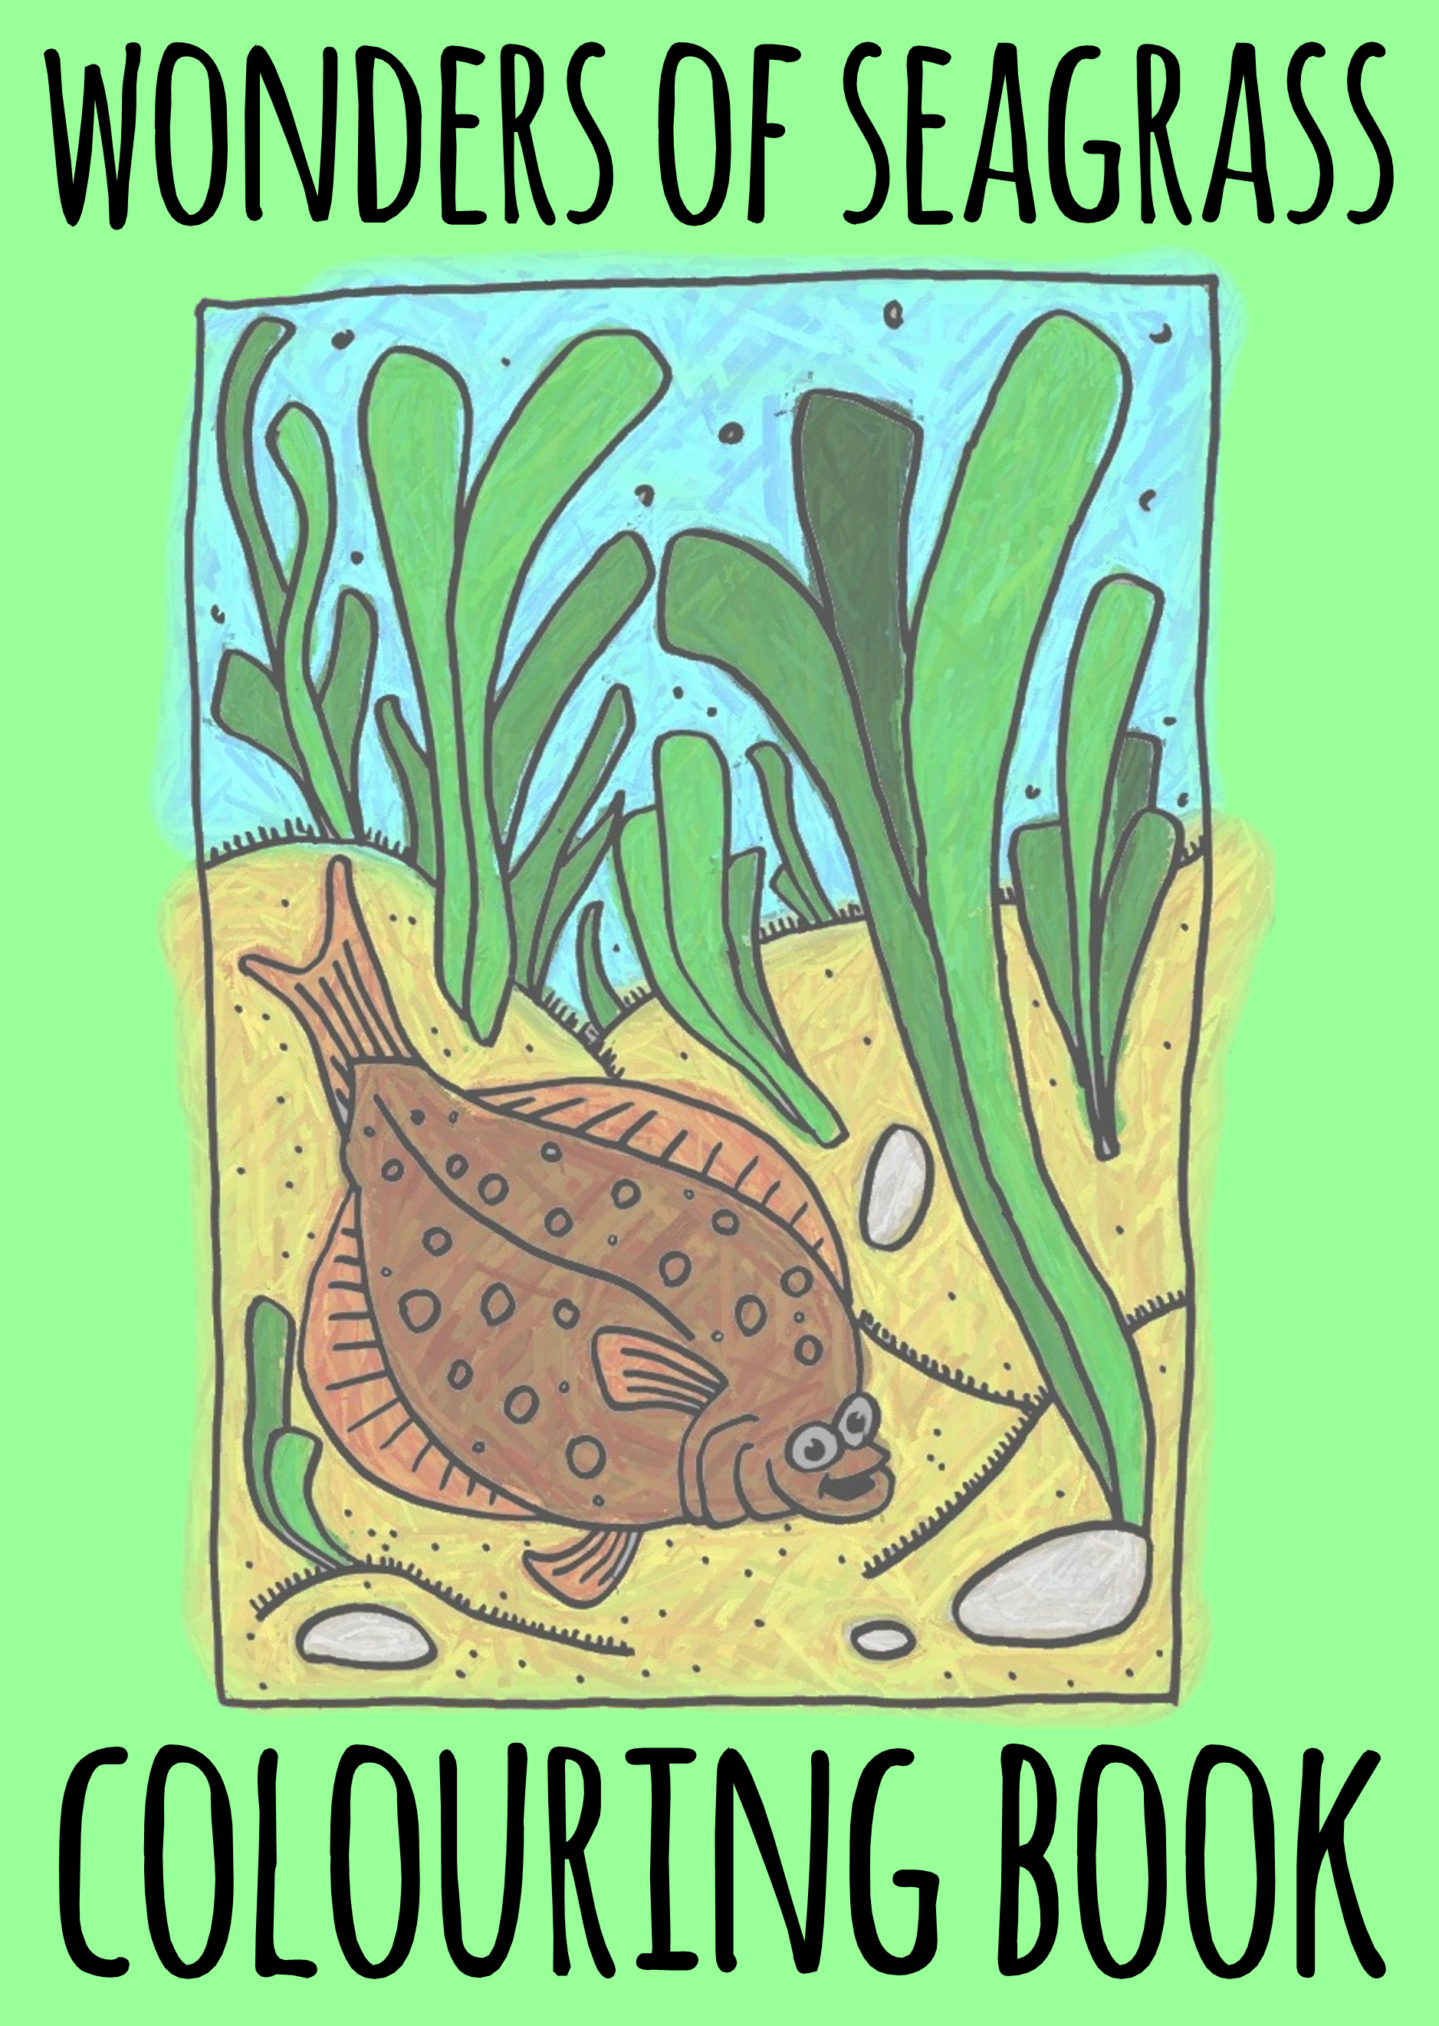

WONDERS OF SEAGRASS

A COLOURING BOOK FOR CHILDREN

ILLUSTRATED BY

BENJAMIN JONES

WHAT IS SEAGRASS?

Seagrass isn’t seaweed, but a group of flowering plants that live in shallow sheltered areas along our coastline. With bright green leaves and waterproof pollen, they form large dense green meadows under the sea. These meadows host many animals of different shapes, colours and sizes. Seagrasses are highly vulnerable to dam-age from humans and are now a protected species. It is estimated that in the UK we have lost over 50% of our seagrass and damage is continuing, protecting what’s left is vital.

COD

The Atlantic Cod is a species of fish. They use Seagrass meadows as important ‘nursery areas’. They grow and develop in the Seagrass meadows until they are fully grown.

Baby Cod love Seagrass meadows. They hide and feed in amongst the leaves when they are small.

Cod are green and brown in colour, with a silver stripe and spots on their backs. When fully grown, they can measure up to 2 meters in length!

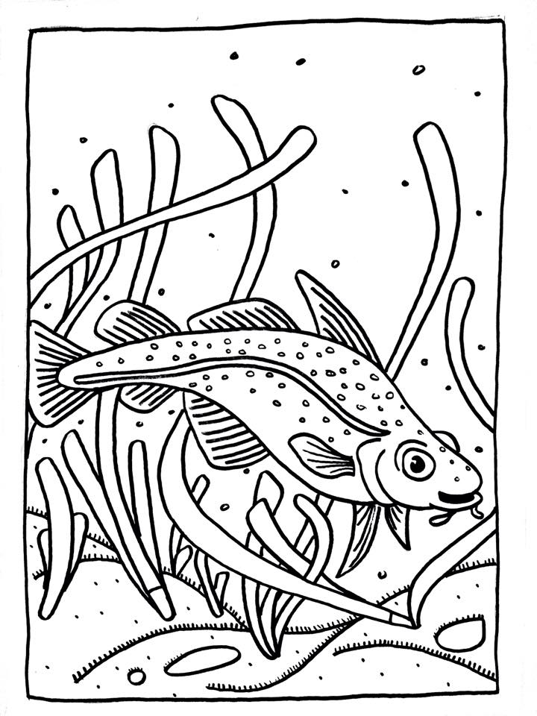
PLAICE

The Plaice is a species of fish. They are a flat fish, who use Seagrass to hide in as they bury themselves in the sand. They feed in the shallow waters where the Seagrass grows.

There is no place like home! Baby Plaice live on the sand in between the Seagrass leaves. They hide here so they are nice and safe.

Plaice have brown skin, with red spots on their backs. They can grow up to 100cm in length.

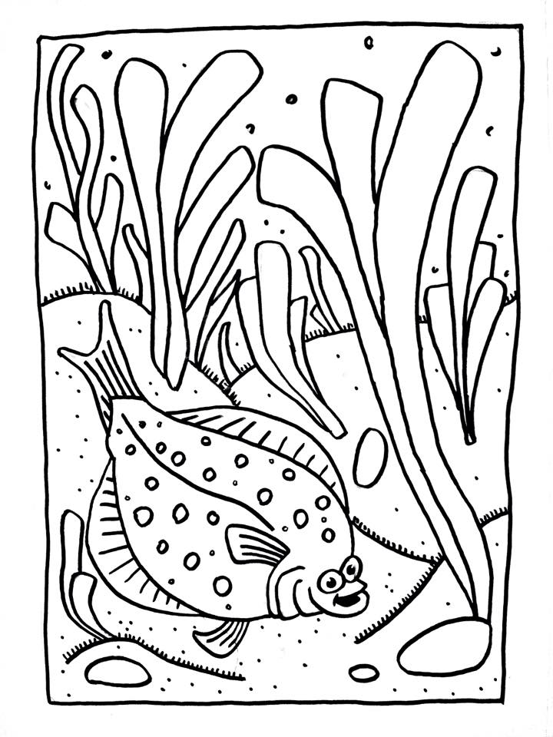
SEAHORSE

The Seahorse is a species of small marine fish. It has a long neck, and head similar to that of a horse. It’s body is long and it swims upright with a curly tail. Seahorses live in Seagrass meadows and swim very slowly.

There are lots of different varieties of Seahorses. Small Seahorses, can grow to be up to 2cm in size and large Seahorses, can grow to be up to 35cm in size.

Many people choose to visit Seagrass meadows to see beautiful seahorses! Seahorses can be seen holding onto Seagrass leaves if you look close enough.

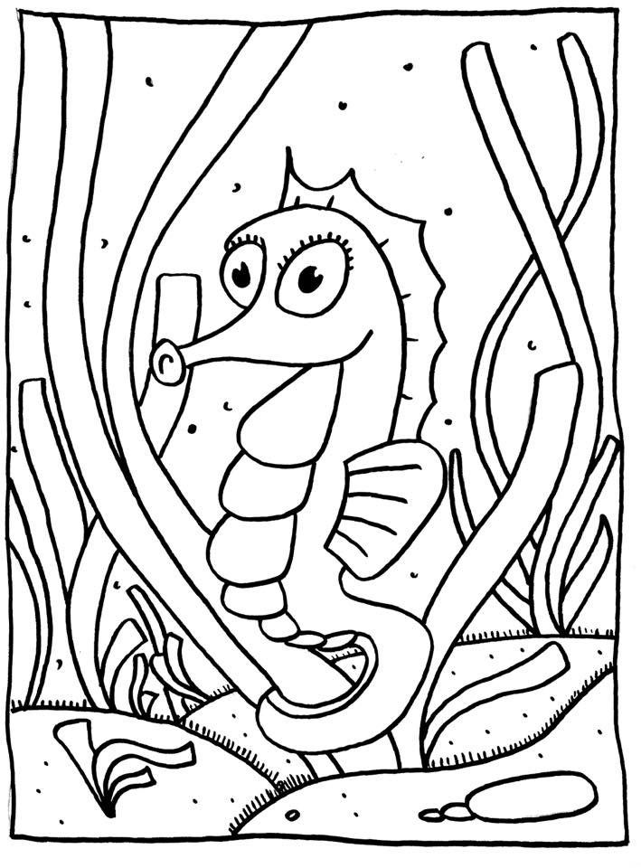
CUTTLEFISH

Cuttlefish are a marine animal, which belongs to the same family as octopus and squid. They have eight legs and two other ‘suckers’, which they use to capture their food.

Cuttlefish lay their eggs in Seagrass so that their babies have a safe place to grow up. In the summer baby cuttlefish play among the Seagrass leaves.

They can grow up to 25cm in length and can change colour depending on their surroundings. They camouflage to protect themselves from predators.

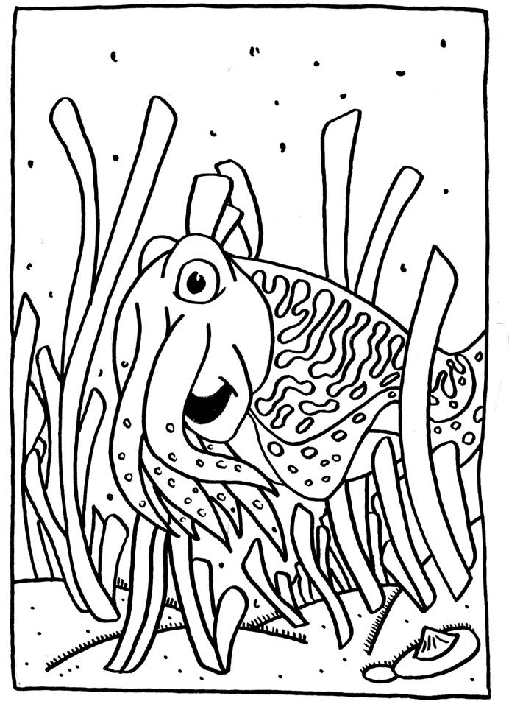
PIPEFISH

Pipefish belong to the same family as the Seahorse. It has a straight body, long nose and a tiny mouth. It is a thin sea animal with a dorsal fin. Pipefish swim very slowly. They live and grow, in Seagrass meadows.

Pipefish love Seagrass so much they look like Seagrass! This means they can play hide and seek in Seagrass and not be seen!

Pipefish are green, to help them camouflage in the Seagrass. This is how they protect themselves against predators. Pipefish can grow up to 35cm in length.

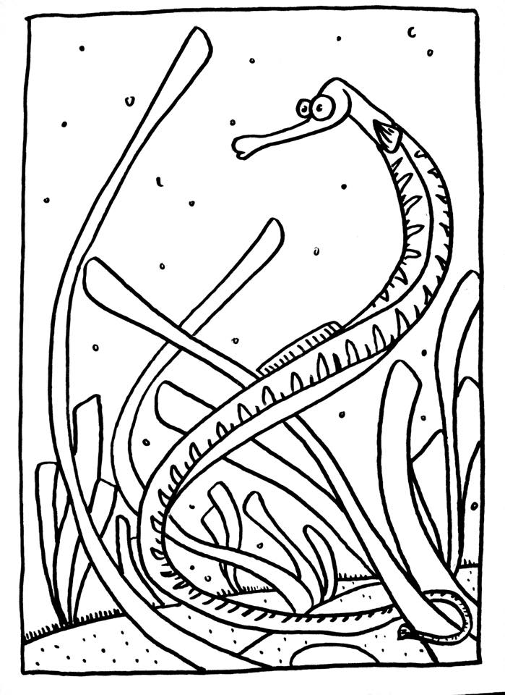
STICKLEBACK

Stickleback fish belong to the same family as Seahorses, and Pipefish. It does not have scales, like most fish. Instead it has hard armour plates and spines in their dorsal fin.

They are light green in colour, with small brown spots and can grow up to 10cm in length.

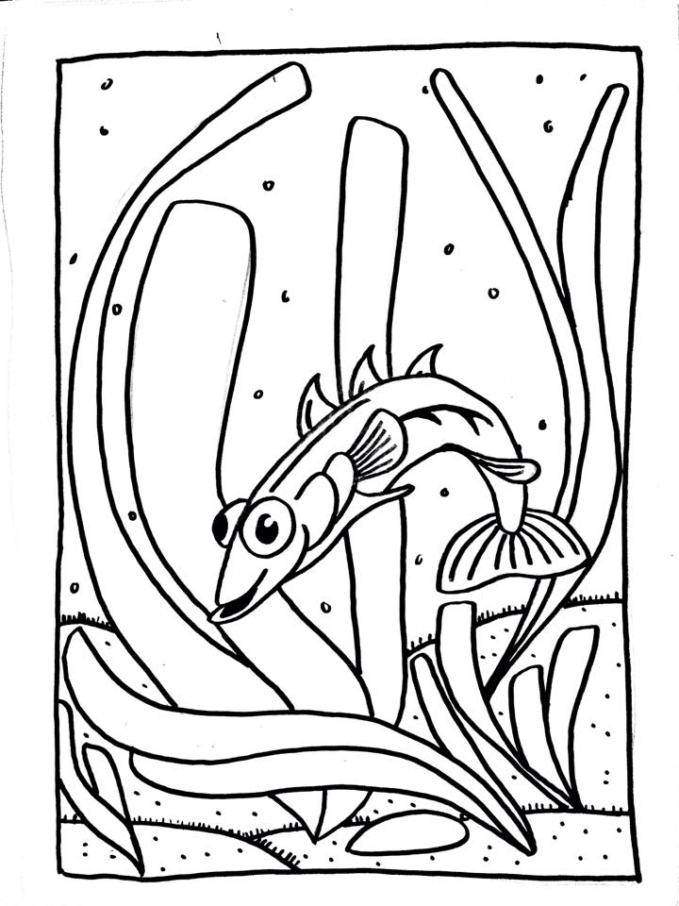
CORKWING WRASSE

The Wrasse live in both rocky areas, and Seagrass meadows. It is a small fish with one long dorsal fin.

Female fish and baby fish are brown, and green in colour. Male fish are brightly coloured. All fish have small lines on their heads and one black spot on the tail. Wrasse can grow up to 25cm in length when fully grown.

Corkwing Wrasse like it when they have lots of Seagrass to swim around in!

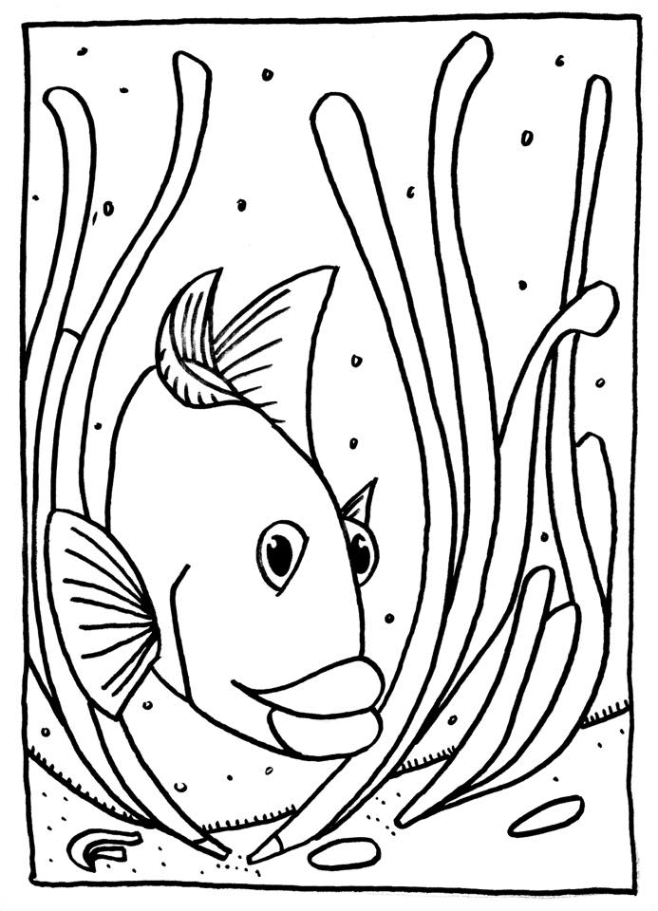
SPIDER CRAB

Spider crabs live in Seagrass Meadows. Some Spider crabs travel up to 100miles during the Autumn during migration. They become friendly with other marine animals when they need to defend themselves against predators.

Spider crabs enjoy eating the sea cucumbers and sea urchins they find in Seagrass meadows.

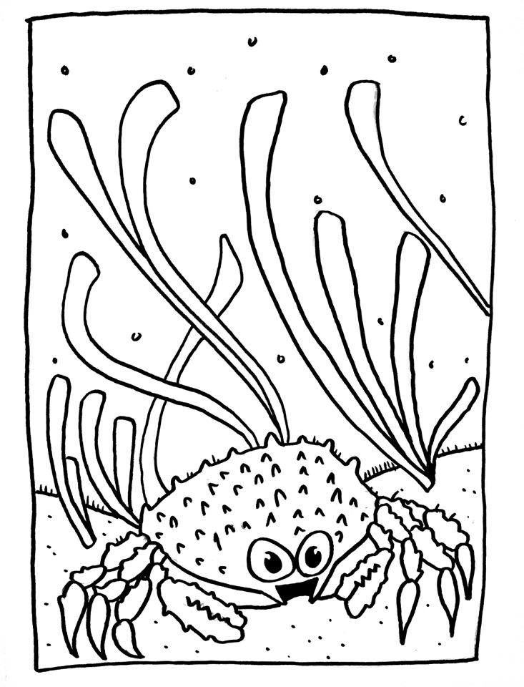
SNAKELOCKS ANEMONE

The Snakelocks Anemone is a Sea Anemone. It has many tentacles, which are dark green in colour with purple tips. They live in shallow Seagrass Meadows and can grow up to 8cm in width.

The Snakelocks Anemone often makes its home in Seagrass meadows, but today many people are keeping them as pets in aquariums.

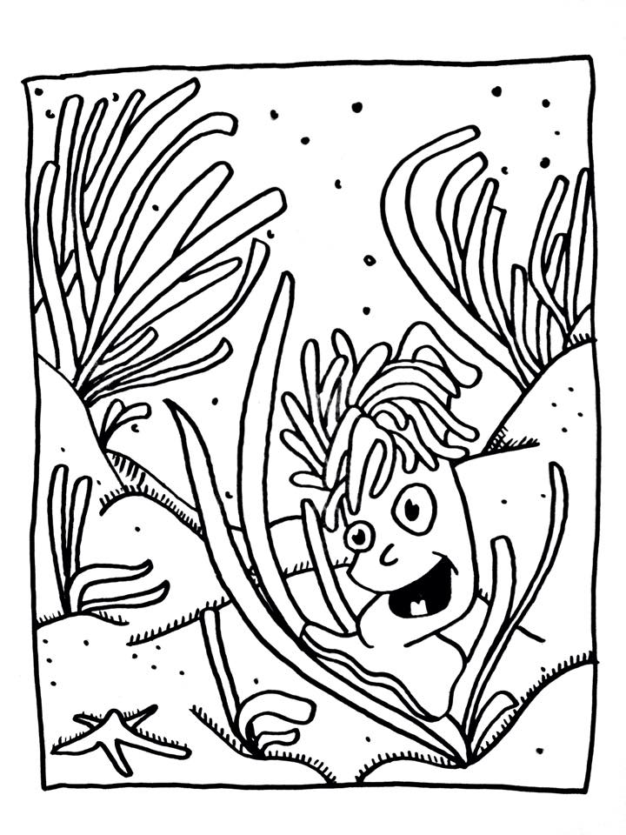
ISOPODS AND GASTROPODS

Isopods are a crustacean. They are small, flat animals with hard shells. Isopods live on the land and in the sea. They have 14 legs and 2 antennae and can grow up to 50cm in length. Isopods are usually grey in colour.

Some Isopods can curl into small balls to defend themselves against predators.

Gastropods are commonly known as snails or slugs. Some varieties live on-land, others live in the sea. They live in shallow, Seagrass meadows.

There are many Isopods and Gastropods that live in Seagrass meadows, they are the small animals that live in, on and under the Seagrass!

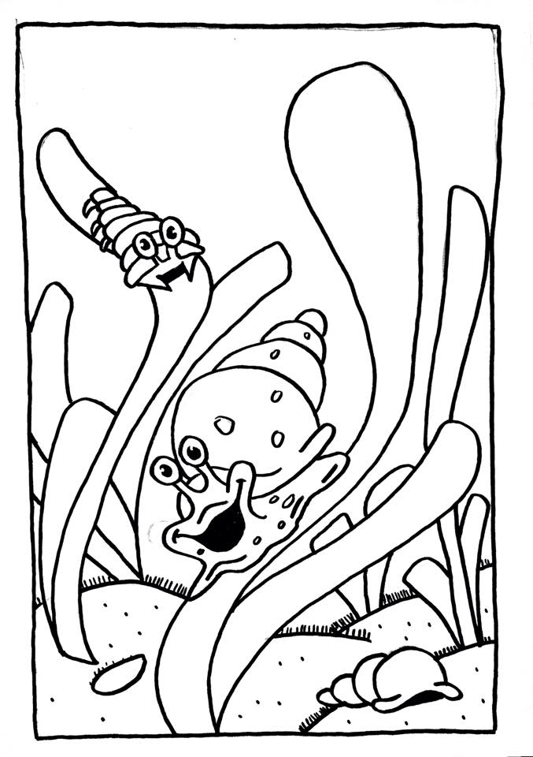
SMALL SPOTTED CATSHARK

The catshark is a species of shark. They are grey in colour, have two dorsal fins and their skin is rough to touch. They can grow up to 1meter in length and have two sets of sharp teeth.

They are often found swimming in Seagrass meadows, because this is where they eat. Catsharks aren’t fussy eaters! They love Seagrass meadows where they can find worms, prawns, shellfish and crabs to eat!

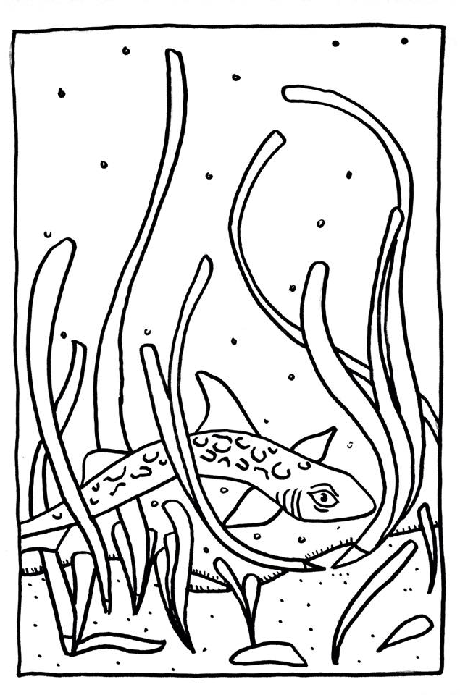
BRENT GEESE

The Brent Goose is a small goose, with a short bill. It measures up to 121cm in size. The goose has a white stomach, the wings, short tail and back are black.

It’s not just sea creatures that love Seagrass. Brent Geese love to eat Seagrass, its one of their favourite types of food! They also breed in these coastal areas.

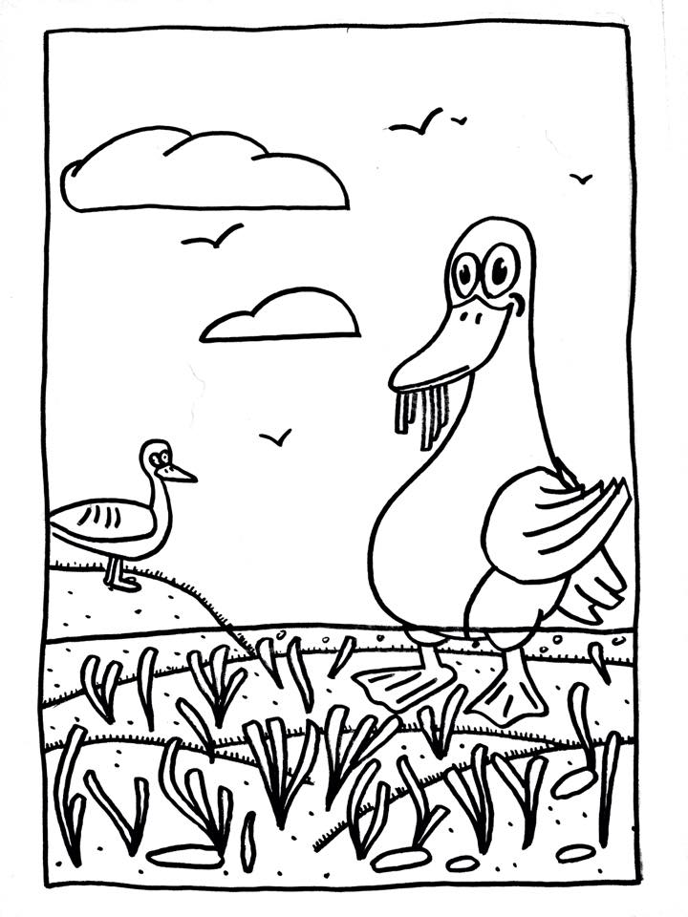
Recalling information
Species | Colour | Size | Feautres/information
Cod
Plaice
Seahorse
CuttleFish
Pike Fish
Stickleback
Corkwing Wrasse
Spidercrab
Snakelocks Anemone
Isopods and Gastropods
Dogfish
Brent Geese

What was your favourite species?
Draw it in the Seagrass below.

FIND OUT MORE AT

www.projectseagrass.org

OR HELP US SPOT SEAGRASS AT

www.seagrassspotter.org

